Create virtual box from the ubuntu.ova file:

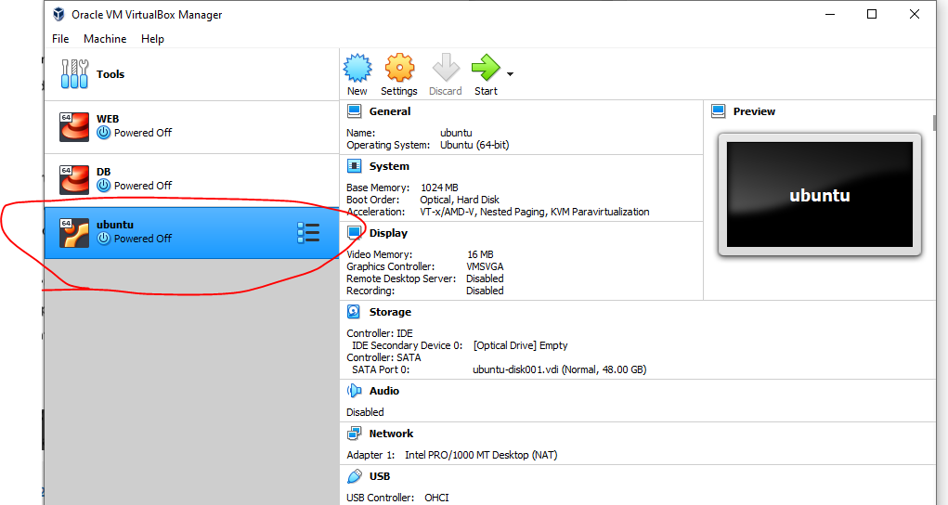

Install some basic packages on the Ubuntu virtual machine:

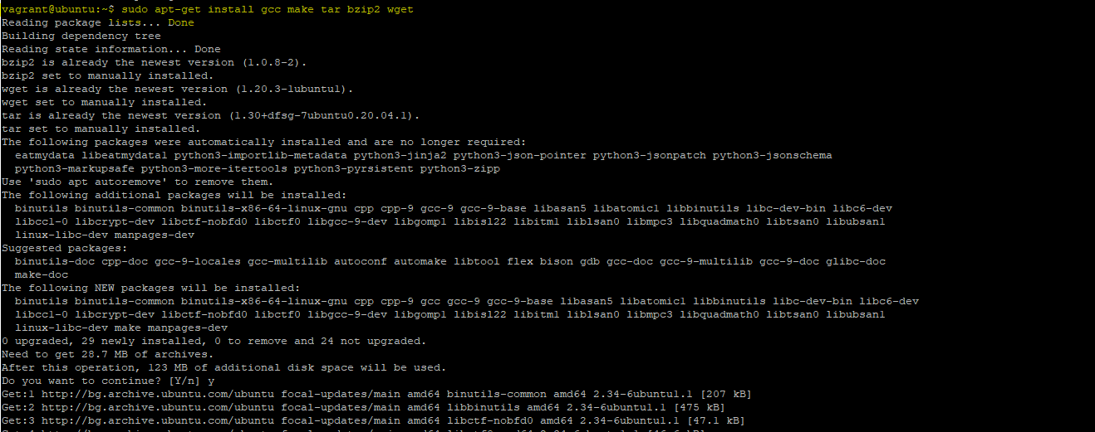

**sudo apt-get install gcc make tar bzip2 wget**

Add vbox additions: sudo apt install build-essential dkms linux-headers-$(uname -r)

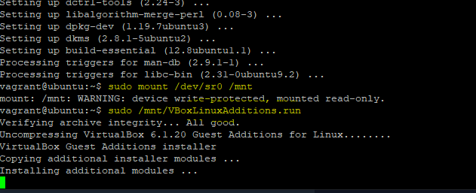

Packaging the vagrant box:

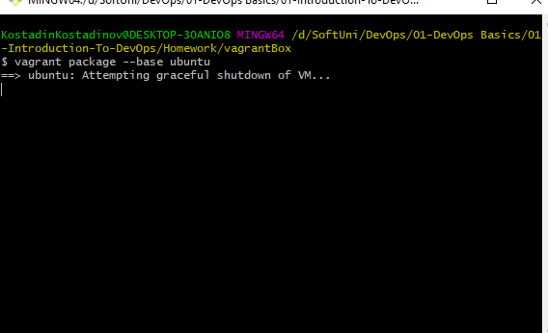

**Creating the vagrant file:**

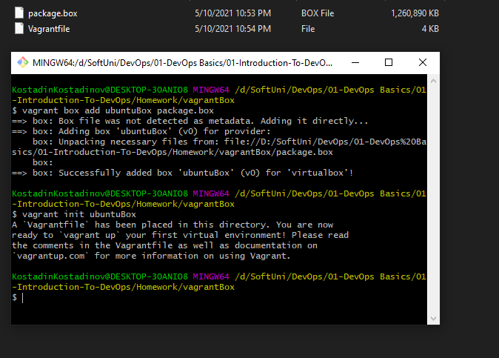

Here is my vm created from the vagrantfile:

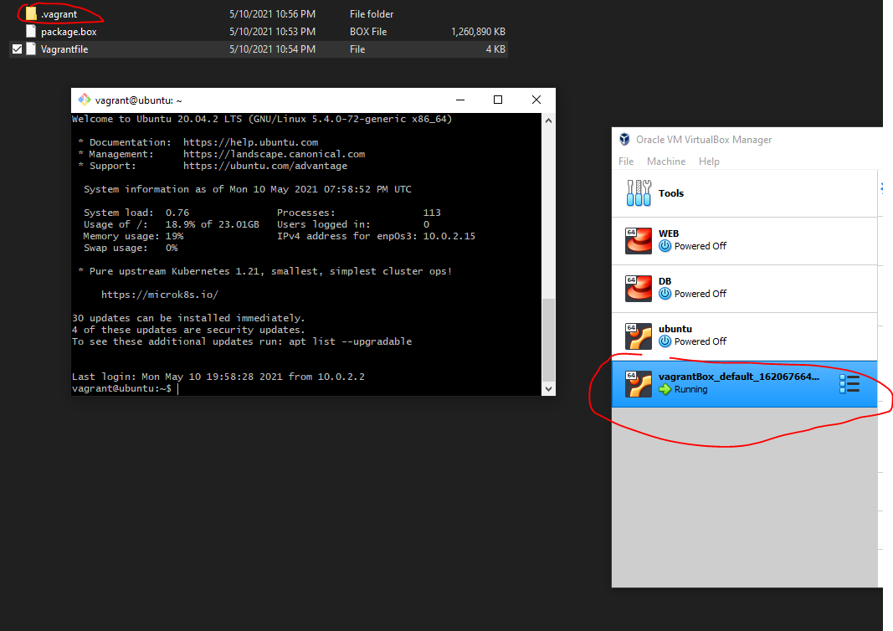

Vagrantfile - <https://pastebin.com/fqJ6ZJkc>

Web.sh - <https://pastebin.com/VXNC0RLN>

Db.sh - <https://pastebin.com/mHF2Fjij>

